


Summary Report
Food Safety & Nutrition
Developed By: Grace Weatrowski, Kate Lingeman, Adela Kaiser, and Megan Cheng
Table of Contents
- Introduction....................................................................................... 4
- Needs Assessment............................................................................. 5
  - Organizational Support Analysis............................................ 6
  - Person Analysis....................................................................... 7
  - Task and KSA Analysis........................................................... 8
- Learning Goals and Training Objectives........................................... 9
  - Learning Goals........................................................................ 10
  - Training Objectives................................................................. 10
- Training Design................................................................................. 11
  - Basic Design........................................................................... 12
  - Learning Theories………………………………….……….. 15
  - Training Content and Learning Checks.................................. 16
- Training Evaluation........................................................................... 20
- References......................................................................................... 24
- Appendices........................................................................................ 25
Acknowledgements
We would like to thank Paul Rosenboom and his Nourish Madagascar team for their time and dedication throughout the creation of this training. We would also like to thank Dr. Warren for his guidance and support.
Introduction
A new training program was developed by our team for the organization, Nourish Madagascar. Nourish Madagascar is a non-profit organization that provides meals to the people of Madagascar to address the challenge of seasonal hunger. During March and April, many resources are used in order to provide seeds and fertilizer for the rice fields. Nourish Madagascar helps by providing school lunches to children, informational sessions, and good quality vegetable seeds to farmers. The current training program has been designed to give structure to the Malagasy people on nutrition and food safety. The use of activities and materials within this manual will allow for an engaging way for the parent volunteers to learn about nutrition and food safety.
After conducting a needs assessment which includes an organization analysis, person analysis, and KSA analysis, developers have created and provided an outline of the training program which includes a welcome, an ice breaker, seven activities, and three infographics. All materials are located in the appendices and are linked to a learning theory within this summary report. Activities were created with the goal of meeting the various training objectives, and each activity has an approximate time length to assist trainers with time management.
The entire training program will last approximately two hours and 30 minutes. If the trainers do not have enough time to complete the whole training program in one day, the training program can also be broken down into three modules that last about 20-50 minutes each. The instructions and materials for the Food Safety and Nutrition training are located in the Trainer and Trainee Manuals.
Needs Assessment
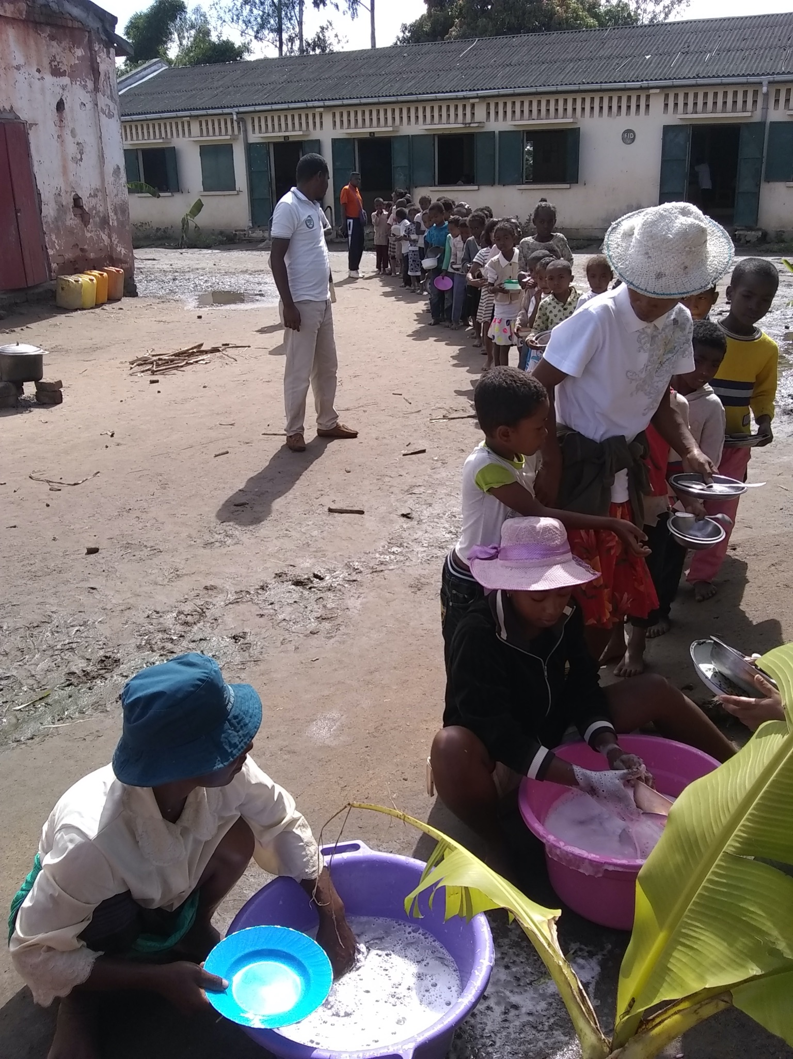
Organization Analysis
The organization of interest, Nourish Madagascar, was utilized in order to create the training course on Food Safety and Nutrition. Nourish Madagascar is a non-profit organization with the mission of addressing the challenge of seasonal hunger by providing meals to the Malagasy people, by partnering with local schools and parent committees. Specifically, Nourish Madagascar engages in this work during the hunger season, including the months of March and April, when all resources have been expended into purchasing seeds and fertilizer to ensure that rice fields can prosper. While the crops are thriving, consequently, there is no money or food available for Malagasy people to survive on. This results in hunger and starvation for many individuals. The Nourish Madagascar vision involves providing school lunch for students, as well as partnering with local farmers to increase available food during the hunger months by holding informational seminars and allocating vegetable seeds of high quality.
Specifying Goals
As analysis of the organizational goals occurs, it is evident that Nourish Madagascar prioritizes the health and safety of the Malagasy people as the main organizational goal. This is emphasized in the development of the Nutrition and Food Safety training course. One area that Nourish Madagascar has not yet approached is informing and teaching the local community about how to practice safe procedures when working with food. Because of this shortcoming, the main goal of the current training program is to inform the Malagasy people on how they can most efficiently reap the nutritional benefits of the meals provided by Nourish Madagascar, while also adopting safe practices in regard to sanitizing water and washing food utensils and dishes. Because Nourish Madagascar aims to improve the health of the Malagasy villagers, the training content takes this goal a step further by providing them with the information they need to be further informed on safe food-centered practices.
Resource Analysis
The main resource required to complete this work was the aid of the cultural liaisons, as well as Nourish Madagascar’s chief executive and founder, Paul Rosenboom. The cultural liaisons were mainly utilized so that the training content developed was sensitive to the Malagasy culture, including language translations from English to Malagasy. The cultural liaisons were also depended on to gather information about the lifestyle of the Malagasy people–for example, how they served food, what types of food they consumed, how they washed their dishes, etc. Paul was also utilized frequently as a point of contact in order to confirm that the training content being developed was aligned with the Nourish mission and values. Lastly, the Nourish Madagascar webpage was frequently referred to as a resource used to gather information on the organization’s goals, history, and efforts. The training course would not have been as seamlessly developed without the guidance and support of these valuable resources.
Person Analysis
A person analysis is necessary to conduct to determine who is being trained as well as the KSAs they are missing. The people we are targeting within Nourish Madagascar are all the parent volunteers who will be preparing and serving the children food. The parent volunteers are being targeted because the main goal of Nourish Madagascar is to provide a daily meal at school in order to ensure that each child is properly nourished. To fulfill this goal, all of the parent volunteers are required to understand each of the objectives and the knowledge, skills, and abilities associated with each objective. It is assumed that all the mothers being trained have the same KSAs; therefore, all need the same training. They will all receive the same training to ensure standardization between all villages. Standardization is critical for our training as many of our objectives require specific criteria that cannot be changed from village to village such as the amount of bleach used to sanitize water and ensuring that each child receives the same amount of food.
Task and KSA Analysis
While there are many different jobs that are essential for the operation of the canteen, the job most responsible for maintaining the food safety and nutrition of the meals served are the parent volunteers that cook and serve the food. According to our cultural liaisons, these volunteer parents are mothers from the villages who have children in the program. These parents are in charge of cooking the food, serving the food, and cleaning up afterwards. Particularly when it comes to serving the food, they will be most in need of the food safety and nutrition training. In order to understand the knowledge, skills, and abilities that the parents need to have in order to safely prepare, serve, and clean up the food and the canteen, we conducted a job/task analysis to determine the KSAs required to adequately perform the job. Much of the information gathered was from the cultural liaisons via email or various messenger apps. A list of the major tasks associated with the job of the parent volunteers is located in Appendix A. A list of the necessary knowledge, skills, and abilities for parent volunteers is located in Appendix B.
Learning Goals and Training Objectives
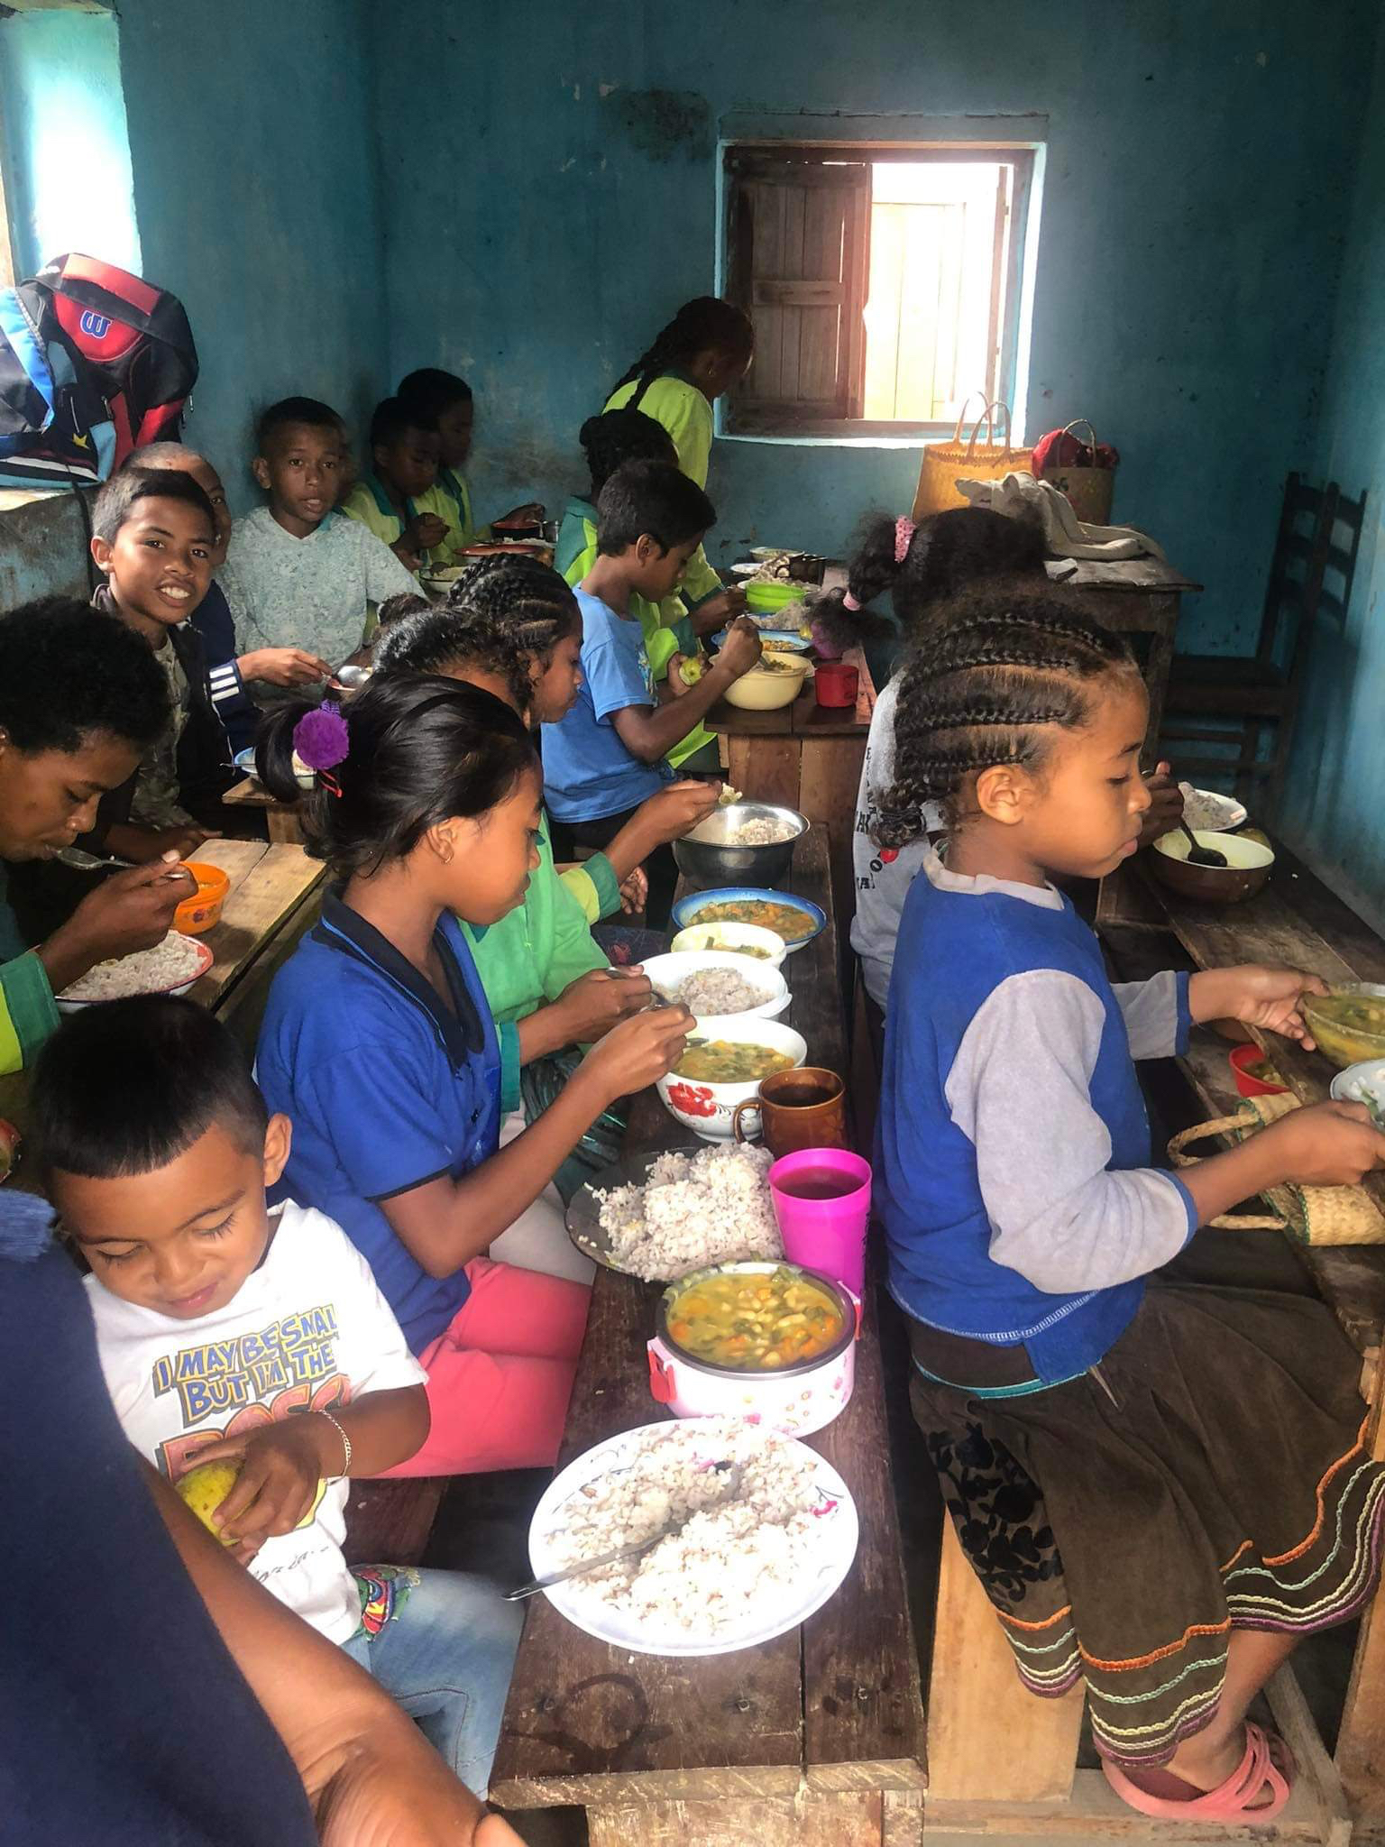
Learning Goals
Parent volunteers will learn…
- To serve the nutritionally appropriate portions of food to the children.
- The importance of serving all the children the same amount of food.
- To wash their hands and dishes for the appropriate amount of time for cleanliness.
- The appropriate amount of bleach to put in water for purification for washing and cooking.
Training Objectives
- Wash hands with soap and water while singing the song, “Zaza Manasa Tanana” before eating or serving each meal.
- Serve the dish with half fruits and vegetables, one quarter protein, and one-quarter carbohydrates in each meal; include 2-3 colors of food on your plate.
- Wash dishes with soap and water until there is no soap or food residue left on the dish.
- Use the appropriate amount of sur’eau or bleach to treat water in order to make it safe for washing dishes, washing fruits and vegetables, and cooking.
- Incorporate values of fairness and sharing when distributing food portions so that each individual receives an equal amount of nutrients.

Training Design
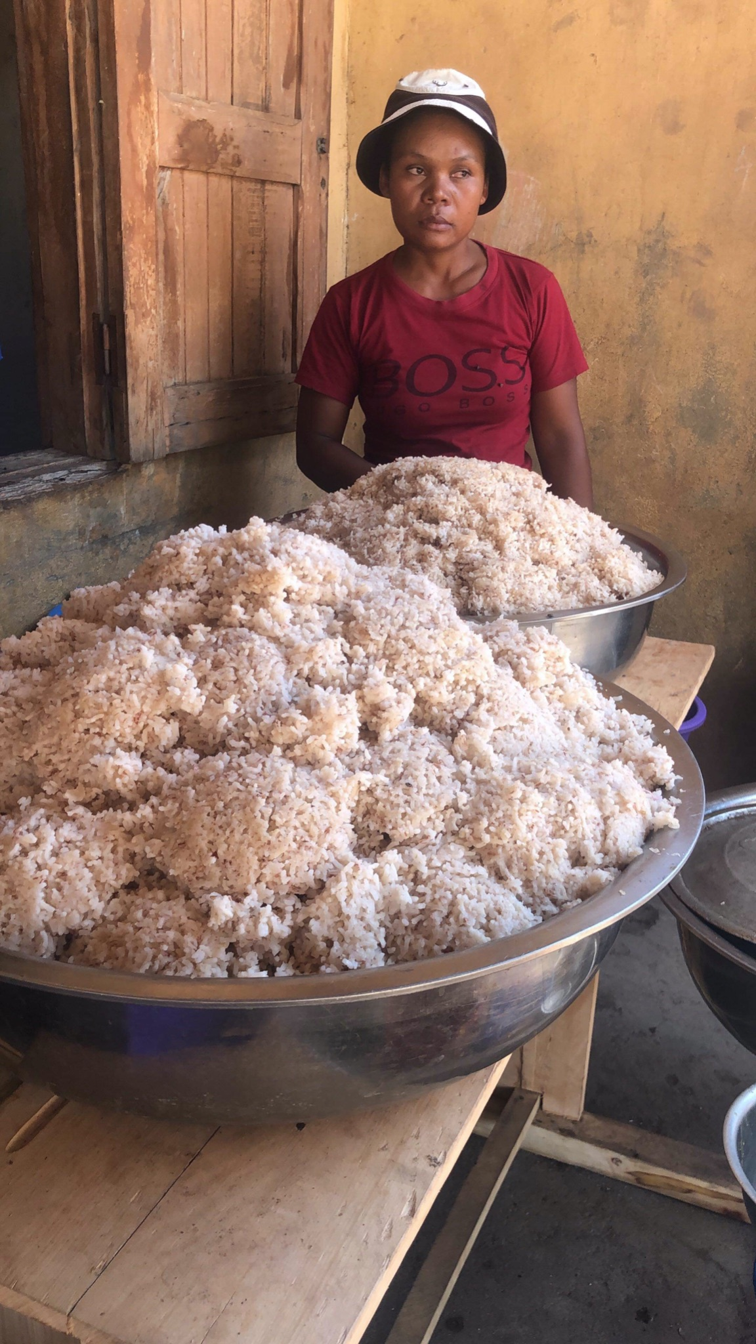
Training Design
Basic Design
In crafting the training design, it was important to acknowledge the trainees' language difference, access to materials, culture, and education levels. To address the language barrier, translations of the training materials, such as training goals, were provided to the cultural liaisons for feedback and revisions in order to ensure clarity of information. To facilitate understanding and retention, infographics were developed for training goals 1 and 3, to employ a varied media delivery for information that might otherwise be confusing to visualize, such as the plate portions training objective. The lack of access to technology was another crucial factor to consider. The group leaned toward utilizing low-tech resources, including infographics and hands-on activities, ensuring accessibility to all volunteers regardless of their familiarity with technology. Moreover, emphasis was placed on cultural context in order to incorporate local values through speeches and interactive training sessions. This can be seen in the role play activity for training objective 6, in which conversation plays an important role in encouraging learning and understanding of why fairness is important for everyone. Speeches and interactive activities were seen as important tools to foster a connection between the training content and the trainees' cultural norms. To underscore this effort, all materials presented to the trainees, whether written or spoken, were intentionally developed at a 4th-grade reading level. By maintaining this language accessibility, the training program sought to promote inclusivity, recognizing the importance of clear communication tailored to the educational backgrounds of those being trained.
To ensure an effective implementation, the training sessions were strategically designed within a 2.5-hour timeframe, striking a balance between comprehensive content delivery and interactive engagement. A structured training schedule allocates 5-20 minutes per training or activity, incorporating two 15-minute breaks to optimize learning retention. The training content was made modular, encompassing three distinct modules: Nutrition, Cleaning, and Fairness. The Nutrition Module covers a lecture and an infographic on nutritional portions, lasting for a total of 20 minutes. The Cleaning Module, comprising infographics on water cleanliness and handwashing, along with an informational lecture on dish cleaning, is covered in 50 minutes. The Fairness Module, involving a roleplay activity on food sharing, has an estimated run-time of 20 minutes. This modular approach offers flexibility to our trainers and trainees, allowing for adaptation to different schedules or constraints while still ensuring each module retains its effectiveness in achieving training objectives. This design not only accommodates diverse learning styles and preferences, but it also addresses potential time limitations or specific organizational needs. While the training was created with the intent of utilizing a massed practice, the option of standalone Modules was made available to ensure changes in the training schedule don't impact the effectiveness of the training.
The decision to employ a massed practice was due to the varied media forms utilized throughout the training, such as infographics, a role play exercise, and an informational discussion. The different training techniques were thought to bring enhanced engagement and retention. Infographics provided a visual and accessible representation of key information, while the role play exercise facilitated hands-on learning and practical application. The informational discussion served as a platform for interactive knowledge-sharing. This approach was guided by the recognition of the need for an efficient yet impactful training program that would accommodate diverse learning styles and preferences among the trainees.
The training methods utilized for the course were required to be developed in alignment with the resources available to the Malagasy people. Therefore, all materials and methods had to be presented in a format that did not require the use of technology. The majority of the course was developed using a traditional lecture and discussion method. Infographics were woven throughout the content to further explain noteworthy concepts in the Nutrition and Food Safety training content. A Soap Mastery Workshop and role-play activity are utilized in the training course to more thoroughly explain the training objectives on proper dish cleaning and practicing fairness and equality when distributing food portions. Utilizing the role-play activity allowed us to encourage active participation and learning in the training program, in order to maximize trainee engagement and increase content learning. The methods chosen for each training objective were given thorough consideration in order to ensure that trainees would be well informed on Nutrition and Food Safety, in a way that complied with resources available to the local community and the training environment of the Malagasy village.

Learning Theories
In order to maximize the results of this training, the training was based on two learning theories: cognitive theory of multimedia learning, and social learning theory. The following table illustrates the method chosen for each objective.
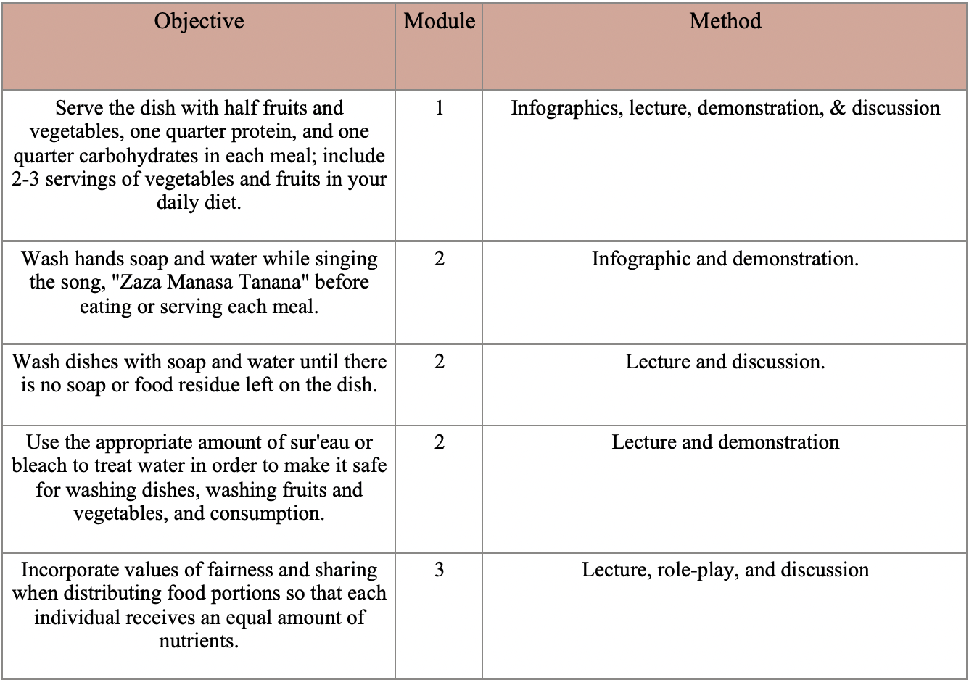
The first theory the activities are based on is the theory of multimedia learning. The theory of multimedia learning states that people tend to learn better from words and pictures rather than just words alone (Mayer & Moreno, 1999). Using this theory, infographics were created in order to better instill the learning objectives instead of only using lectures. The infographics will also be posted around areas where they are needed to serve as a quick reminder of what they learned during the trainings.
The second theory that the activities are based on is the social learning theory proposed by Albert Bandura (1977). Social learning theory is the process where an individual can learn new behaviors by observing the actions of others. In order for social learning to be successful, the theory requires that the individual pays attention, is able to retain the information, is able to reproduce the behavior, and is motivated to imitate the behavior.
Training Content and Learning Checks
Washing Hands Infographic and Activity
The washing hands infographic and activity was designed to teach the trainees how to properly wash their hands for the correct amount of time in order to serve and eat food with clean hands. This training activity used the social learning theory as it will be demonstrated in front of the trainees first. This training objective also uses the theory of multimedia learning as it uses an infographic that illustrates the correct way to wash hands and the amount of time it should take as well. Using a Malagasy song about washing hands is another tool that was used in order for the trainees to remember how long to wash their hands for. The infographic will be posted around hand washing stations so there will be a reminder on how to properly wash their hands after the training is completed.
Nutritional Lecture and Infographic
The Nutritional Portions infographic and lecture was designed to ensure that the trainees understand the importance of receiving nutrients from different sources such as fruits, vegetables, proteins, and carbohydrates. Using the theory of multimedia learning, an infographic will be provided for an easier way of understanding how the plate should be laid out. The lecture and discussion portion of the training will be used to instill the importance of why different nutrients are needed to maximize healthiness. This training design utilizes the theory of multimedia learning as it uses an infographic as well as a lecture and discussion to ensure that the knowledge will be committed to long-term memory.
Soap Mastery Workshop
The cleaning dishes activity was designed for trainees to understand how to properly wash dishes so they can eat off of clean plates. Using the classical learning theory and social learning theory, the trainees will undergo an informational lecture, gaining insights into the importance of using soap, the benefits of hot water, and step-by-step guidance for thorough dishwashing. This theoretical foundation is reinforced through engaging discussions, allowing trainees to absorb key concepts, and understand the broader impact of their actions on community health. The activity places an emphasis on knowledge acquisition and thoughtful discussions to ensure the trainees can comprehend and internalize the best practices possible for maintaining clean dishes and contributing to a safer living environment within their respective village.
How to Clean your Water Infographic and Demonstration
The How to Clean your Water infographic was designed to ensure that the trainees understand the correct way to sanitize water so that it can be used for drinking, washing hands, and washing dishes. An infographic will be posted around the bleach sanitizing areas so it will always be accessible if need be. Due to time restrictions, a full demonstration will not be used because it takes one hour for water to be completely sanitized. Instead, a short demonstration will be provided to show how much water and bleach are used to safely sanitize water. This activity uses the theory of multimedia learning as it uses an infographic as well as a short demonstration.
Fairness Role-Play
The fairness role-play activity was designed to instill an understanding of the importance of distributing the same amount of food to every individual. Role-playing uses social learning theory as there will only be four volunteers participating in the role-play and the rest of the trainees will be watching and observing. After the role-play, a discussion will be held to talk about what they noticed was wrong and right which allows everyone to take part in the activity.
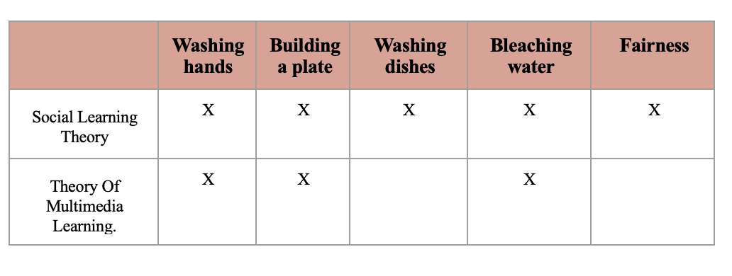
Knowledge, Skills, and Abilities Trained by Each Method
- Wash hands with soap and water while singing the song, “Zaza Manasa Tanana” before eating or serving each meal. (Handwashing Infographic)
  - Knowledge of proper handwashing procedures.
  - Knowledge of the “Zaza Manasa Tanana” handwashing song.
  - Skill in washing their hands with soap and purified water for at least 20 seconds.
- Serve the dish with half fruits and vegetables, one quarter protein, and one-quarter carbohydrates in each meal; include 2-3 servings of vegetables and fruits in your daily diet. (Nutritional Portions Infographic and Nutritional Facts Lecture)
  - Knowledge of proper nutritional portions to serve each child.
  - Knowledge of how many food colors are required for serving a nutritional plate of food.
  - Knowledge of the importance of providing nutritional meals to the children.
  - Skill in serving the children ½ a plate of fruits and vegetables, ¼ a plate of carbohydrates, and ¼ a plate of protein without error.
  - Skill in serving the children 2-3 different colors of food on their plates.
- Wash dishes with soap and water until there is no soap or food residue left on the dish. (Activity- Soap Mastery Workshop)
  - Skill in washing dishes until there is no food residue left on them.
  - Skill in cleaning up the canteen in preparation for the next day’s parent volunteers.
- Use the appropriate amount of Sur’Eau or bleach to treat water in order to make it safe for washing dishes, washing fruits and vegetables, and cooking. (How to Clean Your Water Infographic)
  - Knowledge of the appropriate amount of bleach or Sur’Eau to add to water in order to purify it.
  - Skill in purifying water for drinking, cooking, and cleaning.
- Incorporate values of fairness and sharing when distributing food portions so that each individual receives an equal amount of nutrients. (Fairness Role-Play Activity)
  - Knowledge of the importance of serving each child the same amount of food.
  - Ability to treat all the children fairly and serve them the same amount of food.

Training Evaluation
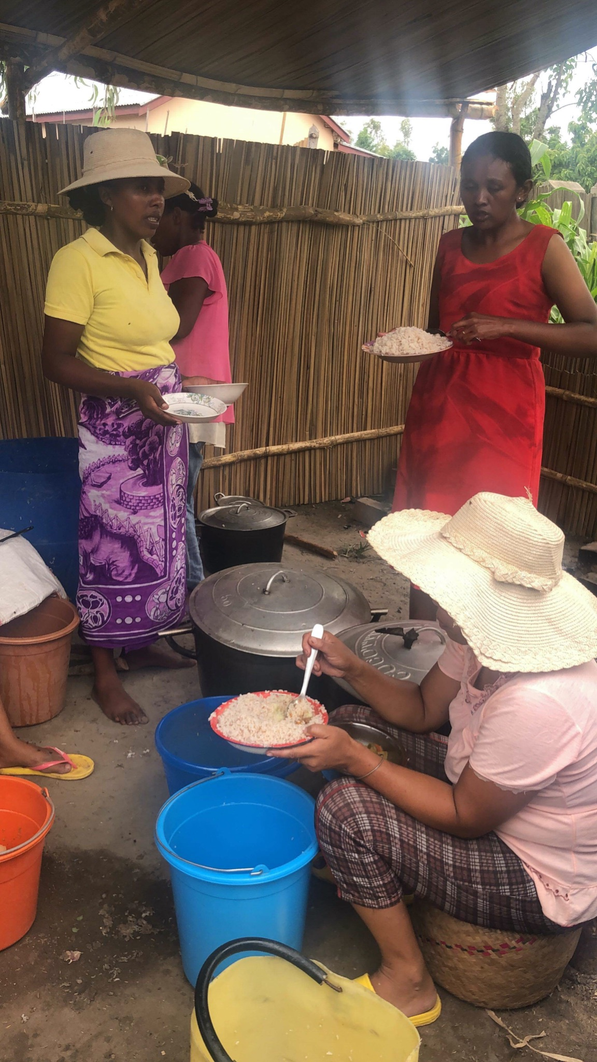
Training Evaluation
The Kirkpatrick model of training evaluation can be applied in order to evaluate the effectiveness of the Nutrition and Food Safety training program. Training evaluation is important because it allows the trainee’s to be assessed on their levels of both transfer and learning accumulated from participating. According to Goldstein and Ford (2001), transfer is “the direct application of the knowledge, skills, attitudes, and behaviors” on the job in the setting mimicked in the training program. This model proposes four different levels of criteria to explore when assessing the transfer of the KSAs taught in the course content. These four levels include reaction, learning, behavior, and results.
Reaction is defined as the trainees' thoughts on the program of interest (Goldstein & Ford, 2001). This mainly involves trainee’s initial reactions to the program, and ignores learning retention. In the current training course, trainee reaction can be assessed by facilitating a group discussion immediately after giving the course, with questions that aim to gather information on participant’s thoughts and feelings regarding the training they experienced prior.
The second level of the Kirkpatrick model involves Learning, which is concerned with measuring the learning of principles, facts, techniques, and attitudes that were specified in the training objectives. More specifically, this level aims to discover which knowledge, skills, and abilities participants have acquired following the training. This can be achieved by gathering quantifiable measures indicative of learning that do not include actual performance on the job (Goldstein & Ford, 2001). Specific to the Nutrition and Food Safety course, assessing trainee learning can be achieved by administering an oral pop quiz before and after the training has been conducted, with items specific to the training objectives. For example, one question included on the pop quiz might be, “How many different colors of vegetables should one include in each meal to achieve a healthy, balanced diet?”. The effectiveness of the training can be gauged by comparing participants' responses before and after the training. A high score on the post-training quiz compared to the pre-training quiz would indicate successful learning outcomes.
In the third level, Behavior involves evaluating trainees' on-the-job performance after completing the training program. It focuses on how effectively they apply the acquired knowledge and skills in their work setting. When evaluating, it is crucial to align on-the-job measures with the specific objectives of the training program, as emphasized by Goldstein and Ford (2001). In the context of the Nutrition and Food Safety training, assessing behavior can be accomplished with observations. For example, someone could provide insights into how well trainees adhere to food safety protocols and integrate nutrition principles into their daily tasks. Observations related to the portions served at lunch and the frequency of washing hands and dishware can be noted by a supervisor or lead committee member. Use of this hands-on evaluation method ensures a practical assessment of how well trainees are integrating the nutrition and food safety practices into their daily routines.
Concluding the four evaluation levels, Results involves assessing the correlation between the training program and the organizational objectives. It provides insight into the impact of the training on organizational outcomes, producing a comprehensive understanding of its efficacy. In the case of Nourish Madagascar, implementing focus groups three months post training can provide qualitative insights into improvements or declines in nutritional awareness and the incorporation of diverse vegetables in daily meals. Focus groups with the Trainees provide insights into the improvements or declines in nutritional awareness and the health of the children within the village. These evaluations not only quantify the success of the training but also guide future enhancements for sustained impact on the well-being of Malagasy villages.

Kirkpatrick Model of Training | Evaluation Method
Reaction | Group Discussion  When: Immediately after the training  What: Trainee thoughts and feelings about the training
Learning | Oral Pop Quiz  When: Before the training and after the training  What: Learning check questions. Ex) How many colors of food should you have on your plate to make it healthy?
Behavior | Observation  When: After the training, on the job  What: Observe the portions of food served, the amount of time spent washing hands, cleanliness of dishes, etc.
Results | Focus Group with Trainees  When: 3 months after the training  What: provide insights into improvements and declines in nutritional awareness and the health of the children (weight before and after training, cases of sickness, etc.)

References
Bandura, A. (1977). Social learning theory. Englewood Cliffs, NJ: Prentice Hall.
Goldstein & Ford (2001). Training in Organizations. (4th ed.). Wadsworth Publishing.
Moreno, R., & Mayer, R. E. (1999). Cognitive principles of multimedia learning: The role of modality and contiguity. Journal of Educational Psychology, 91(2), 358–368. https://doi.org/10.1037/0022-0663.91.2.358
Nourish Madagascar. (n.d.). https://www.nourishmada.org/home
USDA My Plate. (2020). What is MyPlate?. USDA MyPlate What Is MyPlate? https://www.myplate.gov/eat-healthy/what-is-myplate

Appendices
Appendix A: Job/Task Analysis - Major Tasks for Parent Volunteers
- Cooking
  - Prepare the food (using their own dishes)- committee plans to buy dishes soon.
  - Prepare the food early so that it is ready for the children at lunch time.
- Serving
  - Serve/distribute food to children at lunchtime.
  - Distribute the same portions of food to each child.
  - Properly portion the food for each child’s plate with ½ of the plate fruits and vegetables, ¼ of the plate carbohydrates, and ¼ of the plate protein.
- Cleaning
  - Wash dishes and tools until there is no food residue left on them.
  - Clean the canteen so that it is prepared for the next day’s parent volunteers.
- Miscellaneous
  - Collect water for cooking, drinking, and cleaning.
  - Purify/ bleach water so that it is prepared for cooking, drinking, and washing hands and dishes.
Appendix B: Job/Task Analysis - Knowledge, Skills, and Abilities Required for Parent Volunteers
- Cooking
  - Skill in preparing/cooking food.
- Serving
  - Knowledge of proper nutritional portions to serve each child.
  - Knowledge of how many food colors are required for serving a nutritional plate of food.
  - Knowledge of the importance of providing nutritional meals to the children.
  - Knowledge of the importance of serving each child the same amount of food.
  - Skill in serving the children ½ a plate of fruits and vegetables, ¼ a plate of carbohydrates, and ¼ a plate of protein without error.
  - Skill in serving the children 2-3 different colors of food on their plates.
  - Ability to treat all the children fairly and serve them the same amount of food.
- Cleaning
  - Knowledge of proper handwashing procedures.
  - Knowledge of the “Zaza Manasa Tanana” handwashing song.
  - Skill in cleaning up the canteen in preparation for the next day’s parent volunteers.
  - Skill in washing dishes until there is no food residue left on them.
  - Skill in washing their hands with soap and purified water for at least 20 seconds.
- Miscellaneous
  - Knowledge of the appropriate amount of bleach or sur’eau to add to water in order to purify it.
  - Skill in purifying water for drinking, cooking, and cleaning.
  - Ability to collect water for drinking, cleaning, and cooking.
  - Ability to read Malagasy at a “3rd grade level”.
Appendix C: Nutritional Portions Infographic
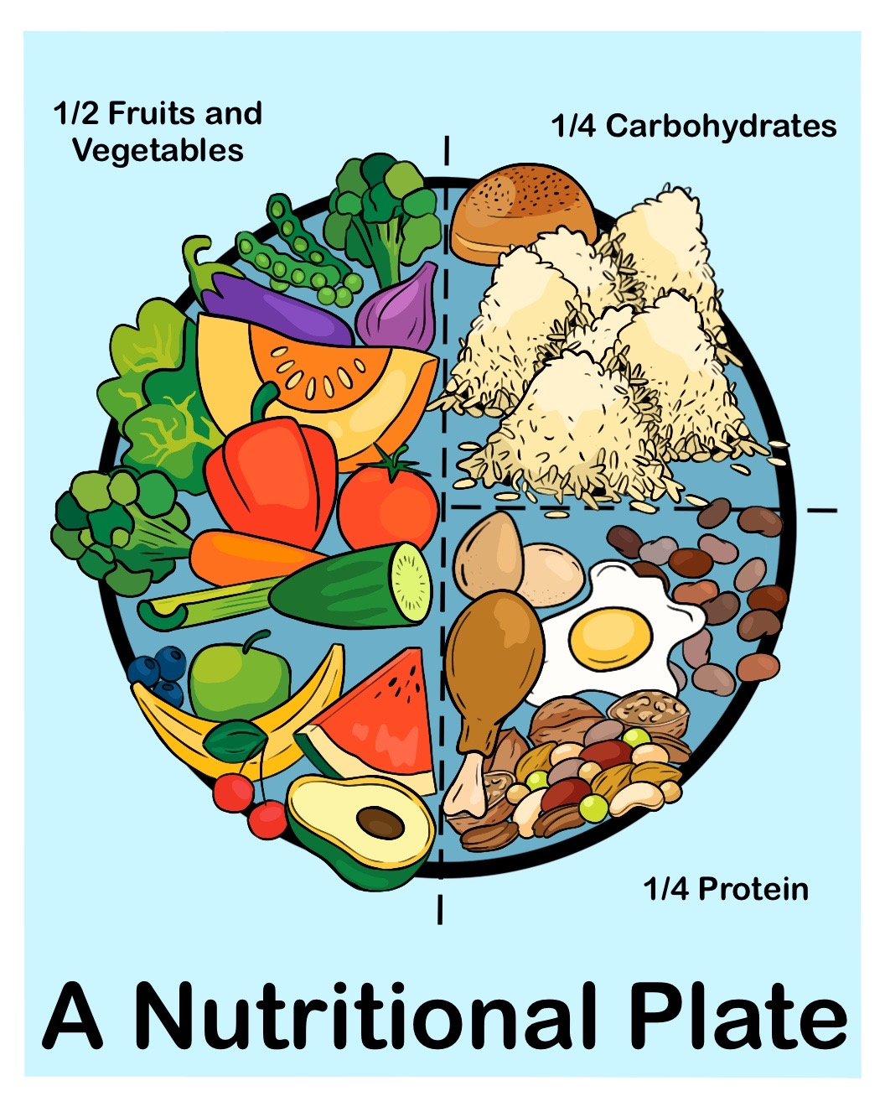
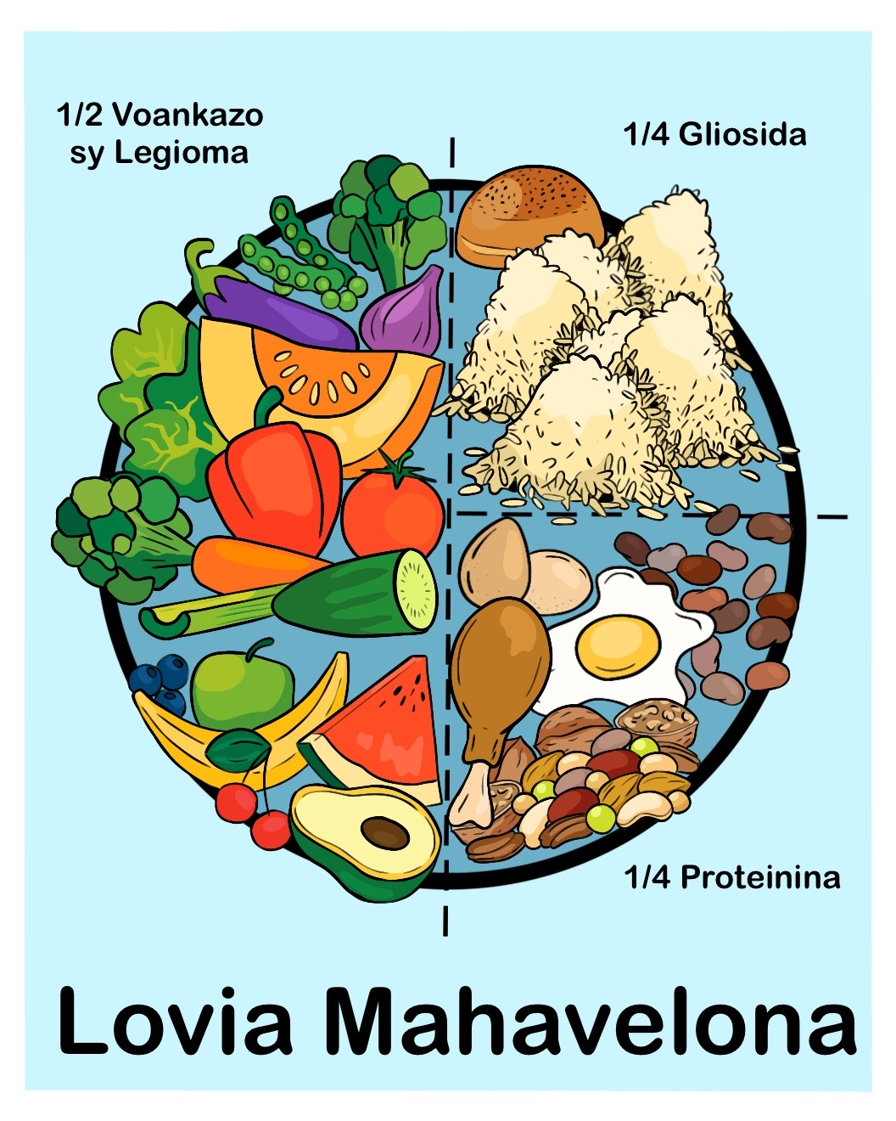
Appendix D: How to Clean Your Water Infographic
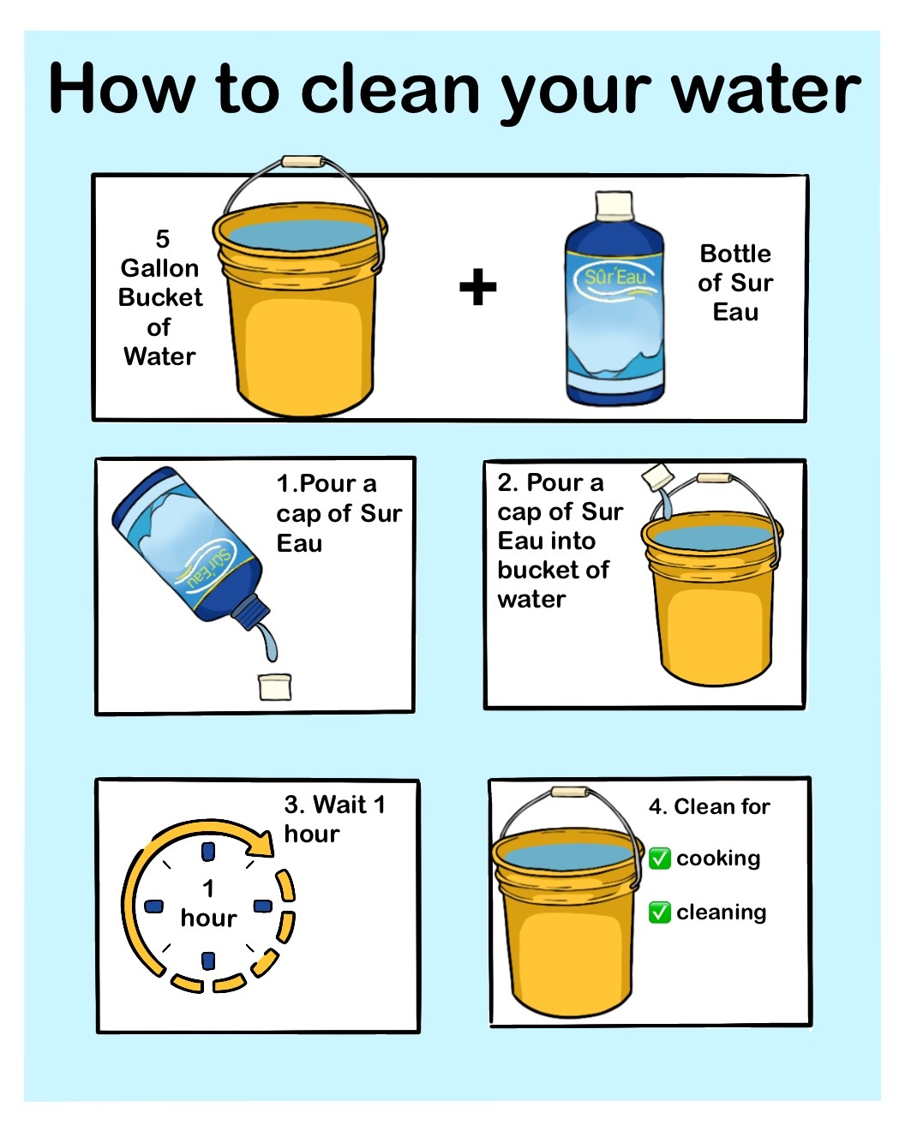
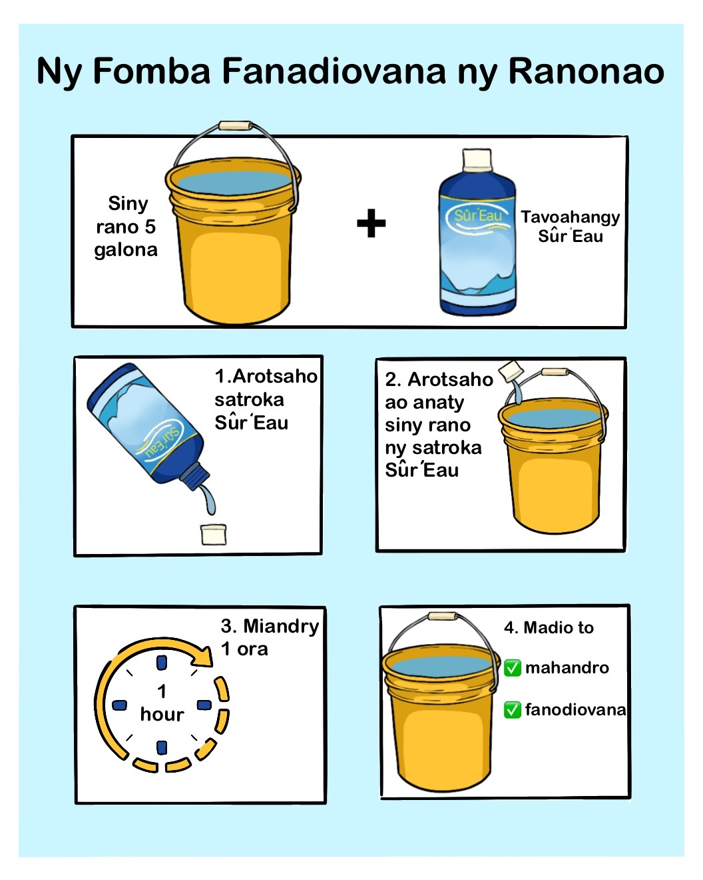
Appendix E: Handwashing Infographic
